|  |
| --- |
| Dinner’s On |

# Design Brief

We provide family style, nutritious dinners for busy families. We do the dinner planning and cooking. You and your family come home and do the eating.

## Concept Details

### Restaurant Name & URL

Dinner’s On

[www.dinnerson.com](http://www.dinnerson.com)

### Main target audience

Busy families with school-aged children who need help and ideas for weeknight dinners.

### Service Details

#### Location Rockville, Bethesda, Potomac, Maryland (suburban)

#### Cost $$ - Affordable

### Menu Options

|  |  |  |  |  |  |
| --- | --- | --- | --- | --- | --- |
| Family Size 4  8 | Main Course Baked chicken  Steak  Fish | Vegetable Tossed salad  Caesar salad  Caprese Salad  Green beans  Peas  Broccoli | Starch Pasta  Roasted white potatoes  Sweet Potatoes  Rice | Dessert Chocolate Cake  assortment of cookies  Vanilla and Chocolate Ice Cream | Drinks milk  soda  lemonade  ice tea |

## Target Audience

The website will focus on the following target audiences:

Roles(groups with similar goals)**:**

* Married adult of families who is in charge of getting dinner on the table
* Divorced single parents who have their kids for several evenings a week and need to get them dinner

### 

### Demographics

### 85% female, 15% male

### age: mid 30s to mid 40s

### education: mostly college educated or above

### occupation: various but, generally white collar

### marital status: married

### children: 2 to 4

### income: but family income of $200K

### location: Rockville, Bethesda, Potomac, Maryland area

### Psychographics

* personality: outgoing; hardworking; responsible; fun
* values: time with family and family dinners; hard work; traditional family
* attitudes: conservative or liberal thinking;
* interests: athletics, movies, current music,
* lifestyles: dad coaches kids’ sports; mom is involved with PTA or Girl Scouts
* User and Client Needs

## User and Client Needs

### User

* The website needs to enable the user to:
* Find out if the restaurant delivers to their area.
* Order food online.
* Customize the dinner that will be delivered.
* Choose the size of the family that will be served.
* See the price before ordering.
* See the past order history.
* Contact someone with questions.

### Client

* To sell food online that will be delivered
* Provide a system for order customization,
* Appear professional and family oriented.
* Communicate that the company is educated on the everyday needs of a family.
* Communicate reliability

# Initial Personas

### 

|  |  |
| --- | --- |
| Amy Johnson - (35 yrs) - The Working Mom married with 3 kids, 5, 7 and 10 | |
|  | works full-time, as does her husband  Amy cooks on Sunday night but by Wednesday, the food is gone and her energy is low. |

|  |  |
| --- | --- |
| Peter Martin - (36 yrs) - The Cool Divorced Dad Peter gets the kids every Wednesday night, but he can’t cook. | |
|  | a busy lawyer with 2 kids, 5 and 7 |

|  |  |
| --- | --- |
| Anna Martinez - (45 yrs) - The Busy Doctor a general surgeon at a local hospital who is on call every week with 2 kids, 14 and 16 | |
|  | Very organized and a good cook but when she gets called in for emergency surgery, she has no choice but to go. She still has to plan for dinner for the kids (and, have something ready when she gets off |

## Outline of Scope

### Content Requirements

Food Menu

* **main courses**
* **side dishes**
* **starch options**
* **desserts**
* **drink options**

Size of meals: **i.e. number to be served ( 4 or 8)**

**Price of meals**

**Images of food**

**About us**

**Testimonials**

**Contact Information**

**FAQ**

* where do you deliver
* how long will it take to deliver
* what are the delivery charges
* description of pricing structure
* Who can I contact?

### Functionality Requirements

*“The user will be able to … “*

* Create an order based on a user’s selections and see the price
* select from the different categories
* select number of people that will be eating
* find out price based on selections
* see when the delivery will arrive
* Place the order
* see totals with taxes and delivery fees
* accept credit card/debit card/PayPal
* send an email reflecting the order
* Estimate delivery time
* Offer the option to create an account to maintain order history
* user authentication
* maintain and view previous orders

# Site Map

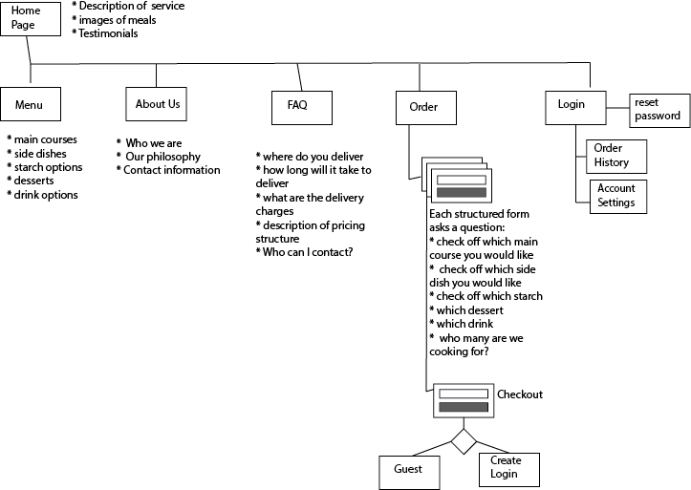

# Wireframes

|  |  |  |  |  |
| --- | --- | --- | --- | --- |
|  |  |  |  |  |
|  |  |  |  |  |
|  |  |  |  |  |
|  |  |  |  |  |
|  |  |  |  |  |

# Mood Board

# 

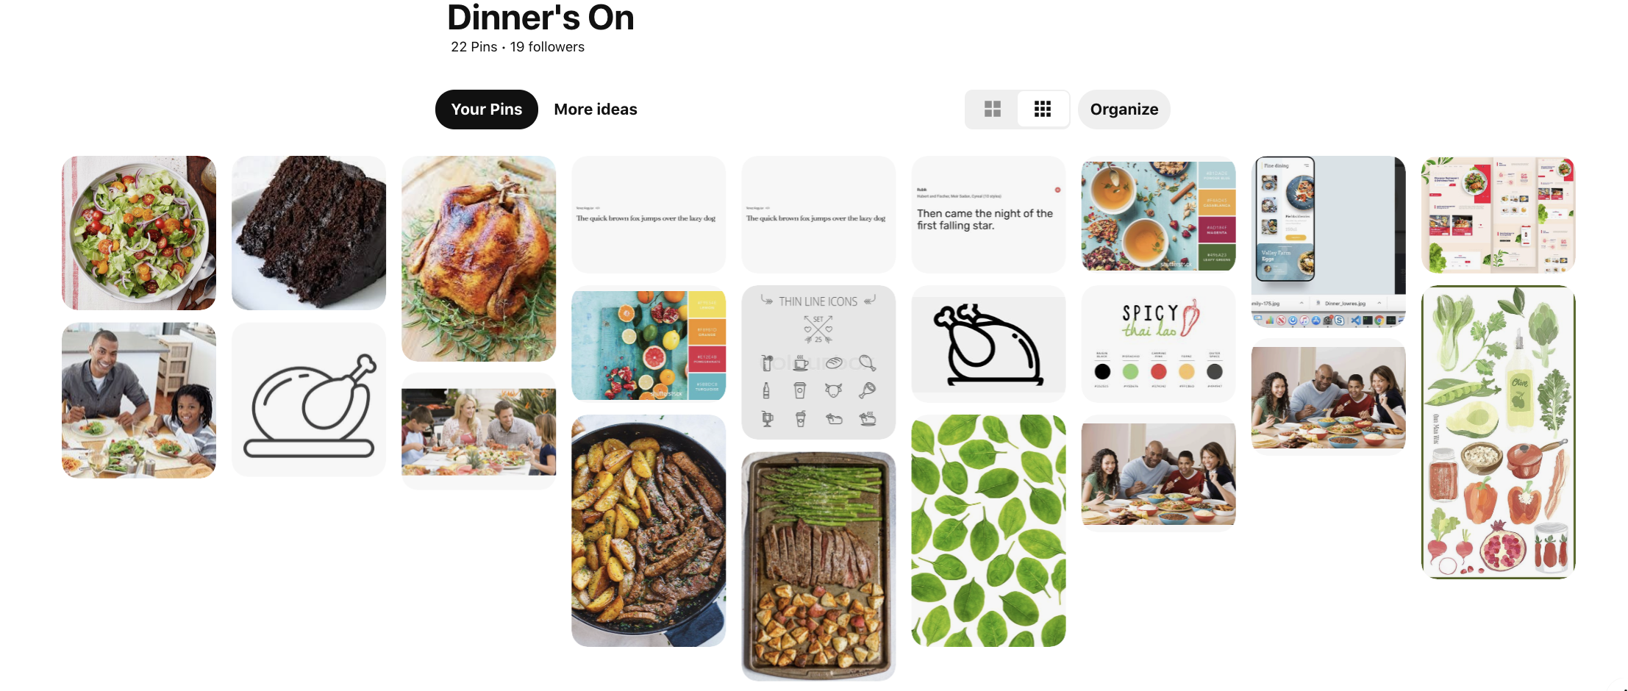

## Full-color Mockups

|  |  |  |  |  |
| --- | --- | --- | --- | --- |
|  |  |  |  |  |

|  |  |  |  |  |
| --- | --- | --- | --- | --- |
|  |  |  |  |  |
|  |  |  |  |  |
|  | | | | |